CS 499 Module One Assignment
Shaban Ghaith

- Self-Introduction: Address all of the following questions to introduce yourself.

  - How long have you been in the Computer Science program?
My name is Shaban Ghaith, and I have been working through the Computer Science program long enough to move from just learning individual programming ideas to thinking more like a developer who has to design, test, secure, and explain a complete solution. At this point in the program, I can see how the earlier courses connect to the capstone because the projects are no longer only about making code run. They are also about making the solution understandable, maintainable, and useful for a real audience.

  - What have you learned while in the program? List three of the most important concepts or skills you have learned.
The three most important skills I have learned are software design, problem solving with data structures and algorithms, and database-backed application development. Software design helped me understand how to break a larger problem into smaller classes, services, screens, and responsibilities. Data structures and algorithms helped me think about efficiency instead of only focusing on whether the answer is correct. Database work helped me understand how applications store, retrieve, protect, and organize data so the system can support real users.

  - Discuss the specific skills you aim to demonstrate through your enhancements to reach each of the course outcomes.
Through my enhancements, I want to demonstrate skills that connect directly to the course outcomes. For the collaboration and decision-making outcome, I want my work to show clear documentation, readable code structure, and user-focused outputs that someone else could review or maintain. For the communication outcome, I plan to explain each enhancement in a narrative that describes the original artifact, the weakness I found, what I changed, and why the change matters. For the algorithmic outcome, I want to show that I can select appropriate data structures, analyze trade-offs, and improve performance. For the tools and techniques outcome, I plan to use practical development tools such as version control, tests, database queries, validation, and structured application layers. For the security outcome, I want to show that I can think ahead about input validation, data privacy, access control, error handling, and other places where a system can be misused.

  - How do the specific skills you will demonstrate align with your career plans related to your degree?
These skills line up with my career plans because I want to move toward software development with a strong focus on building reliable full-stack or backend systems. The enhancements will let me show more than basic coding. They will show that I can improve an existing project, explain technical decisions, work with data, and think about the user and the organization at the same time.

  - How does this contribute to the specialization you are targeting for your career?
The specialization I am targeting is application/software development with backend and database skills. This ePortfolio will support that direction because it will include examples of design improvement, algorithmic thinking, and database enhancement. Together, those areas show the kind of developer I want to become: someone who can build practical systems, improve existing code, and make technical choices that are secure and useful.

- ePortfolio Set Up:

  - Submit a screen capture of your ePortfolio GitHub Pages home page that clearly shows your URL.
    - You already have a repository in GitHub where you uploaded projects in previous courses. Your ePortfolio will reside in GitHub but can link to work at other sites, such as Bitbucket.

  - Use the GitHub Pages link in the Resource section for directions on:
    - How to create your GitHub website and publish code to GitHub Pages
    - Issues, such as adding links to other sites

  - Paste a screenshot of your GitHub Pages home page with your URL clearly showing in the space below.

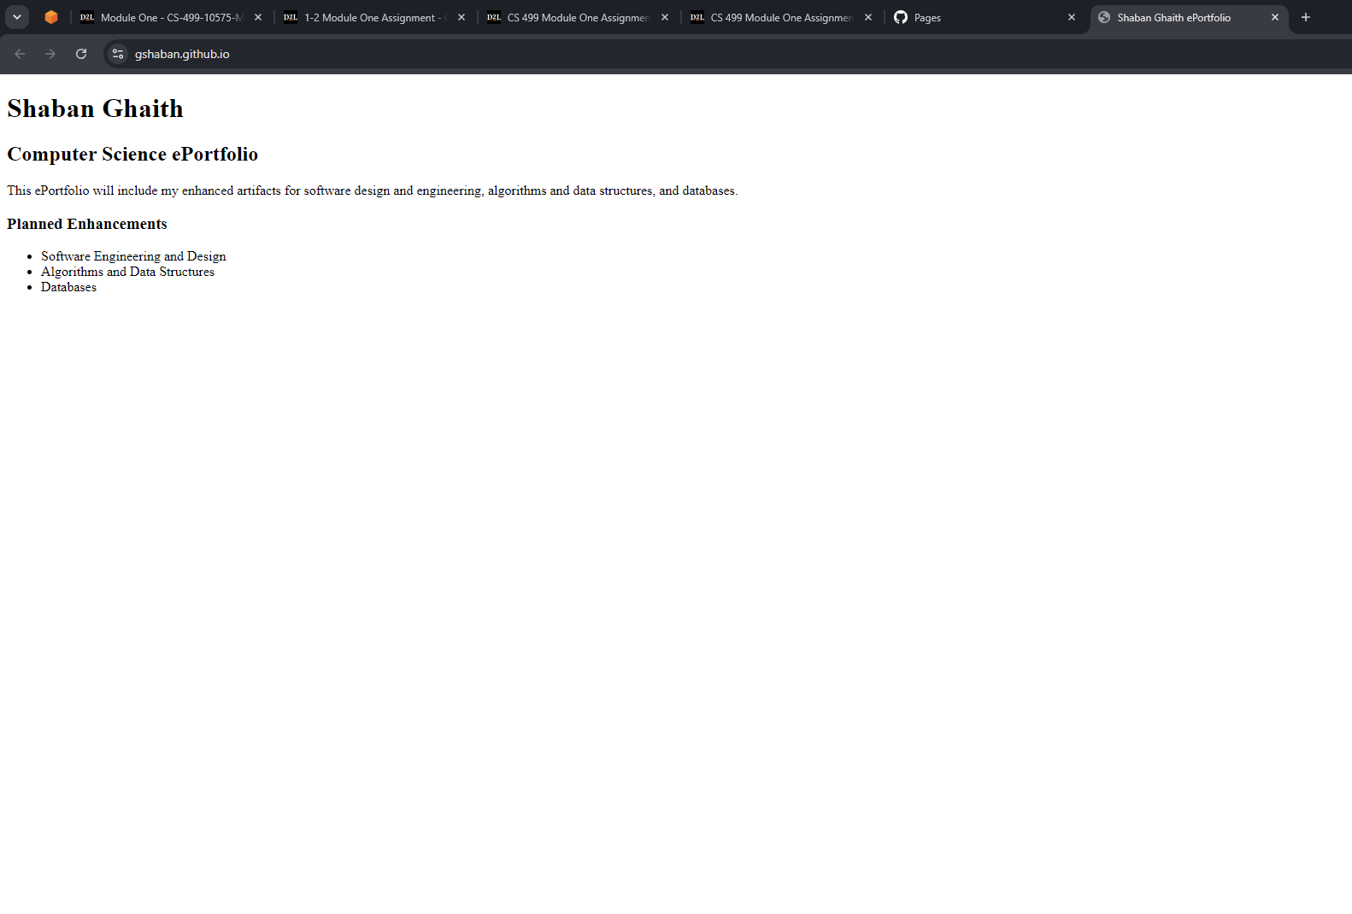
- Enhancement Plan:

  - Category One: Software Engineering and Design
    - Select an artifact that is aligned with the software engineering and design category and explain its origin. Submit a file containing the code for the artifact you choose with your enhancement plan.

Artifact selected: CS 320 Contact Service application.
This artifact fits the software engineering and design category because it is focused on application structure, service logic, validation rules, and maintainable code. The original artifact came from CS 320: Software Testing, Automation, and Quality Assurance. In its original form, the project demonstrated basic object creation, service methods, and unit tests for contact data. For the capstone, I plan to use it as a starting point and enhance it into a stronger, more professional application design.

Note: Your artifact may be work from the following courses:

- IT 145: Foundation in Application Development
- CS 250: Software Development Lifecycle
- CS 260: Data Structures and Algorithms
- IT 315: Object Oriented Analysis and Design
- CS 320: Software Testing, Automation, and Quality Assurance
- CS 330: Computational Graphics and Visualization
- CS 340: Advanced Programming Concepts
- CS 350: Emerging Systems Architectures and Technologies
- CS 360: Mobile Architecture and Programming
- IT 365: Operating Environments
- IT 380: Cybersecurity and Information Assurance
- CS 405: Secure Coding
- CS 410: Reverse Software engineering
- IT 340: Network and Telecommunication Management
- IT 380: Cybersecurity and Information Assurance

    - Describe a practical, well-illustrated plan for enhancement in alignment with the category, including a pseudocode or flowchart that illustrates the planned enhancement.

My enhancement plan is to refactor the Contact Service into a cleaner layered design. I will separate the model, service layer, validation logic, and persistence logic so the project is easier to maintain and test. I also plan to add stronger input validation, clearer exception handling, and a simple persistence option so contacts are not only stored in memory. I will expand the test suite to cover normal cases, edge cases, and invalid input. This will move the project beyond a small class assignment and make it closer to a reusable application component.
Pseudocode for the planned enhancement:
START ContactService request
Receive action: create, update, delete, or search contact
Validate contact ID and required fields
IF validation fails THEN
return clear error message and stop request
END IF
IF action is create THEN
check that contact ID is unique
save contact through repository layer
ELSE IF action is update THEN
find existing contact
apply approved field changes
save updated contact
ELSE IF action is delete THEN
remove contact by ID
ELSE IF action is search THEN
return matching contacts
END IF
Log result for debugging and review
END ContactService request

For this category of enhancement, consider improving a piece of software, transferring a project into a different language, reverse engineering a piece of software for a different operating system, or expanding a project’s complexity. These are just recommendations. Consider being creative and proposing an alternative enhancement to your instructor.

Think about what additions to include to complete the enhancement criteria in this category. Since one example option is to port to a new language, that is the kind of scale that is expected. This does not mean you need to port to a new language but instead have an equivalent scale of enhancement. Underlying expectations of any enhancement include fixing errors, debugging, and cleaning up comments, but these are not enhancements themselves.

    - Explain how the planned enhancement will demonstrate specific skills and align with course outcomes.

      - Identify and describe the specific skills you will demonstrate that align with the course outcome.

This enhancement will demonstrate object-oriented design, separation of concerns, validation, exception handling, test planning, and maintainable code organization. It will also show that I can evaluate the limits of an earlier project and improve it in a practical way instead of only cleaning up comments or renaming variables. The added tests will support quality assurance, while the layered design will make the project easier for another developer or stakeholder to understand.

      - Select one or more of the course outcomes below that your enhancement will align with.

Aligned course outcomes: collaborative environments and organizational decision-making; professional-quality written and visual communication; computing solutions using computer science practices and standards; innovative techniques, skills, and tools; and a security mindset through validation, error handling, and protection of user data.

Course Outcomes:

- Employ strategies for building collaborative environments that enable diverse audiences to support organizational decision-making in the field of computer science.
- Design, develop, and deliver professional-quality oral, written, and visual communications that are coherent, technically sound, and appropriately adapted to specific audiences and contexts.
- Design and evaluate computing solutions that solve a given problem using algorithmic principles and computer science practices and standards appropriate to its solution while managing the trade-offs involved in design choices.
- Demonstrate an ability to use well-founded and innovative techniques, skills, and tools in computing practices for the purpose of implementing computer solutions that deliver value and accomplish industry-specific goals.
- Develop a security mindset that anticipates adversarial exploits in software architecture and designs to expose potential vulnerabilities, mitigate design flaws, and ensure privacy and enhanced security of data and resources.

  - Category Two: Algorithms and Data Structures

- Select an artifact that is aligned with the algorithms and data structures category and explain its origin. Submit a file containing the code for the artifact you choose with your enhancement plan. You may choose work from the courses listed under Category One.

Artifact selected: CS 300 Binary Search Tree eBid Auction Search application.
This artifact fits the algorithms and data structures category because it uses a binary search tree to store, search, and retrieve bid records from CSV data. The original artifact came from CS 300: Data Structures and Algorithms. The local project files include BinarySearchTree.cpp, CSVparser.cpp, CSVparser.hpp, and the eBid monthly sales CSV data files. In its original version, the program loaded bid records and allowed lookup through a tree-based structure. For the capstone, I plan to enhance this project so it demonstrates stronger algorithmic thinking, clearer performance trade-offs, and better handling of real input data.

- Describe a practical, well-illustrated plan for enhancement in alignment with the category, including a pseudocode or flowchart that illustrates the planned enhancement.

My enhancement plan is to improve the Binary Search Tree eBid application by making the data loading, tree operations, and search features more complete and reliable. I will strengthen CSV input validation, improve how duplicate or invalid bid records are handled, and add traversal options so users can view bids in sorted order. I also plan to compare the binary search tree approach with the earlier vector and hash table assignments from CS 300, then explain the time-complexity trade-offs for insertion, search, and traversal. If the tree becomes unbalanced with certain data patterns, I will address that limitation by documenting the risk and adding a practical mitigation, such as sorted input warnings or a planned balanced-tree improvement.
Pseudocode for the planned enhancement:
START loadBidsIntoTree
Open eBid CSV file
For each row in the file
Validate bid ID, title, fund, and amount fields
IF row is valid THEN
Create bid object
Insert bid into binary search tree by bid ID
ELSE
Record skipped row with reason
END IF
END FOR
Display number of loaded bids and skipped records
END loadBidsIntoTree
START searchAndDisplayBid
Receive bid ID from user
Search binary search tree from root node
IF bid ID matches current node THEN
display bid details
ELSE IF bid ID is less than current node ID THEN
move to left child
ELSE
move to right child
END IF
IF search reaches empty node THEN
show clear not-found message
END IF
END searchAndDisplayBid
START printSortedBids
Perform in-order traversal of binary search tree
Display each bid in sorted bid ID order
END printSortedBids

For this category of enhancement, consider improving the efficiency of a project or expanding the complexity of the use of data structures and algorithms for your artifact. These are just recommendations. Consider being creative and proposing an alternative enhancement to your instructor. Note: You only need to choose one type of enhancement per category.

Think about what additions to include to complete the enhancement criteria in this category. Since one example option is to port to a new language, that is the kind of scale that is expected. Perhaps you might increase the efficiency and time complexity of an algorithm in an application and detail the logic of the increased time complexity. Remember, you do not need to port to a new language but instead have an equivalent scale of enhancement. Underlying expectations of any enhancement include fixing errors, debugging, and cleaning up comments, but these are not enhancements themselves.

- Explain how the planned enhancement will demonstrate specific skills and align with course outcomes.

  - Identify and describe the specific skills you will demonstrate to align with the course outcome.

This enhancement will demonstrate binary search tree design, recursive insertion and search, in-order traversal, CSV parsing, input validation, and time-complexity analysis. It will also show that I can choose a data structure based on the problem instead of only using a simpler list or vector. The main trade-off I will explain is that a binary search tree can make searching more efficient than a linear scan, but its performance depends on tree balance and input order.

  - Select one or more of the course outcomes listed under Category One that your enhancement will align with.

Aligned course outcomes: algorithmic computing solutions and trade-off management; professional communication through the enhancement narrative and pseudocode; innovative computing techniques and tools; and collaborative decision-making because the final output helps users search, review, and understand bid records more effectively.

  - Category Three: Databases

    - Select an artifact that is aligned with the databases category and explain its origin. Submit a file containing the code for the artifact you choose with your enhancement plan. You may choose work from the courses listed under Category One.

Artifact selected: CS 340 Grazioso Salvare Animal Rescue Dashboard / MongoDB application.
This artifact fits the databases category because it is centered on storing, querying, filtering, and displaying animal shelter records from a database. The original artifact came from CS 340: Advanced Programming Concepts. The project used MongoDB and a dashboard-style interface to retrieve and present data. For the capstone, I plan to enhance it so the database layer is more secure, more efficient, and more useful for decision-making.

    - Describe a practical, well-illustrated plan for enhancement in alignment with the category, including a pseudocode or flowchart that illustrates the planned enhancement.

My enhancement plan is to improve the MongoDB data layer and dashboard functionality. I will add stronger CRUD operations, input validation, indexed fields for common searches, and more advanced queries or aggregation pipelines for rescue-type filtering and reporting. I also plan to separate database access into its own module instead of mixing query logic directly into interface code. If time allows, I will add role-aware behavior so read-only users and editing users do not have the same level of access.
Pseudocode for the planned enhancement:
START dashboardRequest
Receive user filter or CRUD request
Validate request fields and user permission level
IF request is read/filter THEN
build safe MongoDB query from approved filters
use indexed fields where possible
return matching records to dashboard
ELSE IF request is create/update/delete THEN
confirm user has edit permission
validate all required database fields
perform database operation
return success or clear error response
END IF
Record database action for troubleshooting
END dashboardRequest

For this category of enhancement, consider adding more advanced concepts of MySQL, incorporating data mining, creating a MongoDB interface with HTML/JavaScript, or building a full stack with a different programming language for your artifact. These are just recommendations; consider being creative and proposing an alternative enhancement to your instructor. Note: You only need to choose one type of enhancement per category.

Think about what additions to include to complete the enhancement criteria in this category. Since one example option is to port to a new language, that is the kind of scale that is expected. Perhaps you might increase the efficiency and time complexity of an algorithm in an application and detail the logic of the increased time complexity. Remember, you do not need to port to a new language but instead have an equivalent scale of enhancement. Underlying expectations of any enhancement include fixing errors, debugging, and cleaning up comments, but these are not enhancements themselves.
    - Explain how the planned enhancement will demonstrate specific skills and align with course outcomes.

      - Identify and describe the specific skills you will demonstrate that align with the course outcome.

This enhancement will demonstrate database design, MongoDB query development, CRUD operations, indexing, input validation, modular database access, and privacy/security thinking. It will also show that I can connect data work to a real user need by making the dashboard better for filtering, reporting, and decision-making. The security portion is important because database applications need to protect data and avoid unsafe or overly broad access.

      - Select one or more of the course outcomes listed under Category One that your enhancement will align with.

Aligned course outcomes: collaborative environments and decision-making through useful dashboard output; professional communication through the database narrative and documentation; computing solutions using appropriate computer science practices; innovative techniques and tools through MongoDB indexes, queries, and aggregation; and a security mindset through validation, permission checks, and safer database access.

- ePortfolio Overall Skill Set

  - Accurately describe the skill set to be illustrated by the ePortfolio overall.
    - Skills and outcomes planned to be illustrated in the code review

The code review will show that I can evaluate my own work honestly and technically. I plan to discuss code organization, readability, design choices, testing, data handling, algorithmic efficiency, and security risks. This will support the outcomes related to communication, computing practices, algorithmic problem solving, and security because I will not only describe what the code does, but also what needs improvement and why.

    - Skills and outcomes planned to be illustrated in the narratives

The enhancement narratives will show my ability to explain technical changes to an audience that may include both technical and nontechnical readers. Each narrative will explain the original artifact, the planned or completed enhancement, the technical skills demonstrated, the course outcomes addressed, and the decisions or trade-offs I made. The narratives will also help connect the work into one portfolio instead of leaving the projects as separate assignments.

    - Skills and outcomes planned to be illustrated in the professional self-assessment

The professional self-assessment will show the overall skill set I have built through the Computer Science program. I plan to discuss growth in software engineering, algorithms, databases, secure coding, testing, communication, and professional development. I will also connect the portfolio to my career goal of becoming a software developer with strong backend and database skills. One question I would like feedback on is whether these three selected artifacts provide enough coverage across all course outcomes, or whether I should adjust one artifact to make the final ePortfolio stronger.
AI Usage Acknowledgment: I used ChatGPT to help draft this plan. I reviewed it and confirm it reflects my own work.

